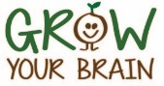
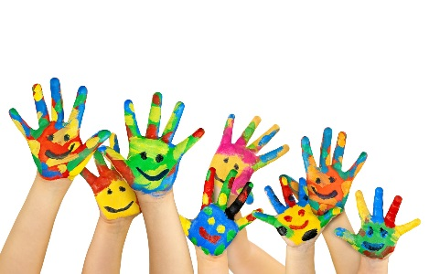

Holly leaves
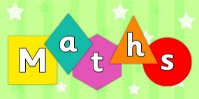
- Cooking – using cups as measurement allows the children to count in ones
- Sharing food – “one for me one for you” or “I’ve got two potatoes but you’ve only got one. How many more do you need?”
- Ordering and comparing – e.g. go on a stick hunt and order the sticks in size
- Following a shopping list – e.g. can you get three tomatoes?
- Read number themed stories using props – Goldilocks and the three bears (set out their breakfast table with three bowls etc)
- Sing or listen to number themed songs using props – 10 green bottles
- Practice writing the numbers (can use different items like beads or buttons to make it more interesting)
- Shape hunt (2d and 3d)
- Estimating how many items there are. Check afterwards by counting.
- Says the number that is one more than a given number
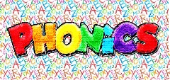
- Use sounds rather than the names of the letters
- Watch Alphablocks Alphabet and follow the actions and sounds
- I spy with sounds using initial sound or “I spy with my little eye a d-o-g”
- Find sounds in signs e.g. when walking around town, can you see a “s” in this sign?
- Find items with the same sound – go on a “s” search (socks, sticks, sofa
- etc)
- Blending and segmenting words (cvc (consonant vowel consonant) for now such as cat, fox etc)
- Clapping sounds in a word (c-a-t would be 3 claps)
- Robot talk – talk like a robot but you can only sound words out using individual sounds (b-a-t not bat). See if the child can then work out what the robot word is.
- Phonic songs (Old Macdonald had a farm, ee I ee I oh, and on that farm he had a p-i-g. What did he have on his farm?)
- Sound flash cards – showing sounds in random order

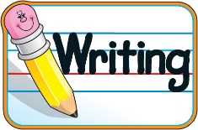
- Write letters to people or characters in a story
- Messy writing (writing in shaving foam, sand or paint)
- Using the attached question sheet when reading a book
- When making a model write on a post-it note what you have made
- Label pictures you have drawn

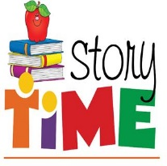
- Make a scene from a story you have read
- Write alternative stories together (change setting or characters)
- Act out a familiar story
- Read a story and draw your favourite character or setting
- Sequence a story (e.g. Get animals that are the same as characters in The Gruffalo. Order the animals in order that they appear in the story)
- When reading a story, leave a blank for a word. Can the child fill in the gap?

- See attached sheet for information

- Taster day – Children taste different types of food. Can do this blindfolded to make it more exciting and try and guess the different foods.
- Make an obstacle course and complete the different movements to get to the end. Encourage the use of prepositional language. Can they guide someone else through the course?
- Play throwing and catching games with different objects (balloons can be fun).
- Follow movements. Brain breaks or Jumpstart Jonny on youtube is good for this.

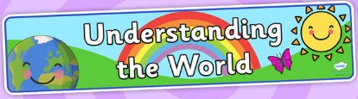
- Quiz members of the family about their occupation.
- Grow a flower/plant and observe the changes over time.
- Can use a computer to complete a simple program (top marks is a good site for math games). Can they use the mouse?
- Create a bug, frog or bee hotel! There is some great information on how to do this on the RSPCB website. Pinterest also have some good ideas.

