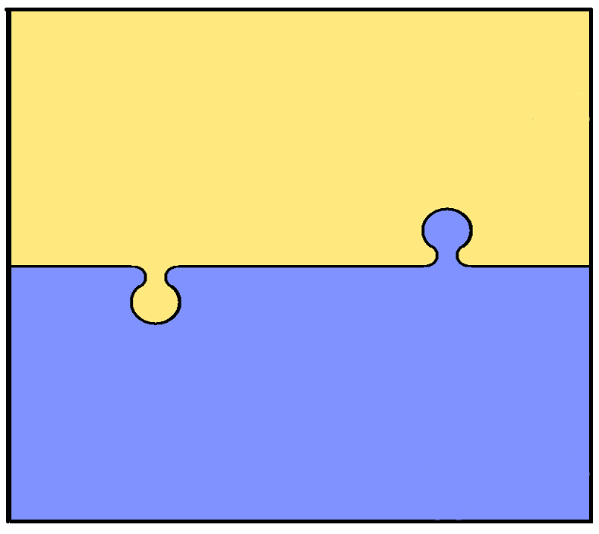

**Year 2 english and maths objectives.**

**Number/Calculation**  
  
•Know 2, 5, 10x tables   
•Begin to use place value (T/U) •Count in 2s, 3s, 5s & 10s   
•Identify, represent & estimate numbers   
•Compare / order numbers, inc. < > = •Write numbers to 100   
•Know number facts to 20 (+ related to 100)  
 •Use x and ÷ symbols   
• Recognise commutative property of multiplication

**Geometry & Measures**  
 •Know and use standard measures •Read scales to nearest whole unit •Use symbols for £ and p and add/subtract simple sums of less than £1 or in pounds  
•Tell time to the nearest 5 minutes •Identify & sort 2-d & 3-d shapes •Identify 2-d shapes on 3-d surfaces •Order and arrange mathematical objects   
•Use terminology of position & movement

**Fractions**   
  
•Find and write simple fractions •Understand equivalence of e.g. 2/4 = 1/2   
  
**Data**   
  
•Interpret simple tables & pictograms •Ask & answer comparison questions •Ask & answer questions about totalling

**Writing**

•Spell by segmenting into phonemes   
•Learn to spell common ‘exception’ words  
•Spell using common suffixes, etc.  
•Use appropriate size letters & spaces  
•Develop positive attitude & stamina for writing  
•Begin to plan ideas for writing   
•Record ideas sentence-by-sentence   
•Make simple additions & changes after proof-reading

**Reading**

Develop phonics until decoding secure

Read common suffixes

Read & re-read phonic-appropriate

books

Read common ‘exception’ words

Discuss & express views about

fiction, non-fiction & poetry

Become familiar with & retell

stories

Ask & answer questions; make

predictions

Begin to make inferences

**Grammar**

•Use . ! ? , and ’   
•Use simple conjunctions   
•Begin to expand noun phrases   
•Use some features of standard   
  
**Speaking & Listening**   
  
•Articulate & Justify answers  
•Initiate & respond to comments •Use spoken language to develop understanding