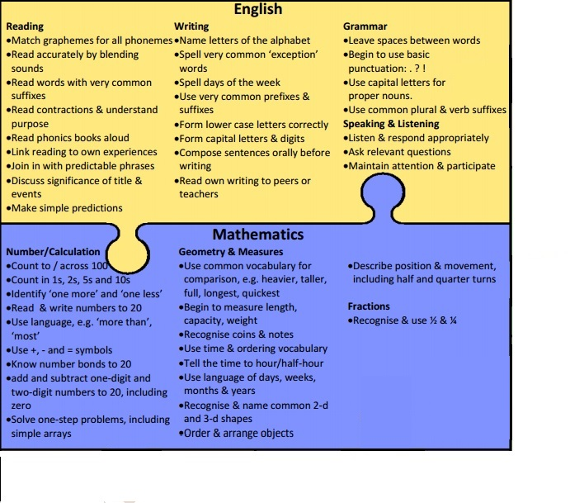
Year 1 English and Maths Objectives Jigsaw

