Curriculum Overview for Holly Berries class. YEAR A. 2016-2017
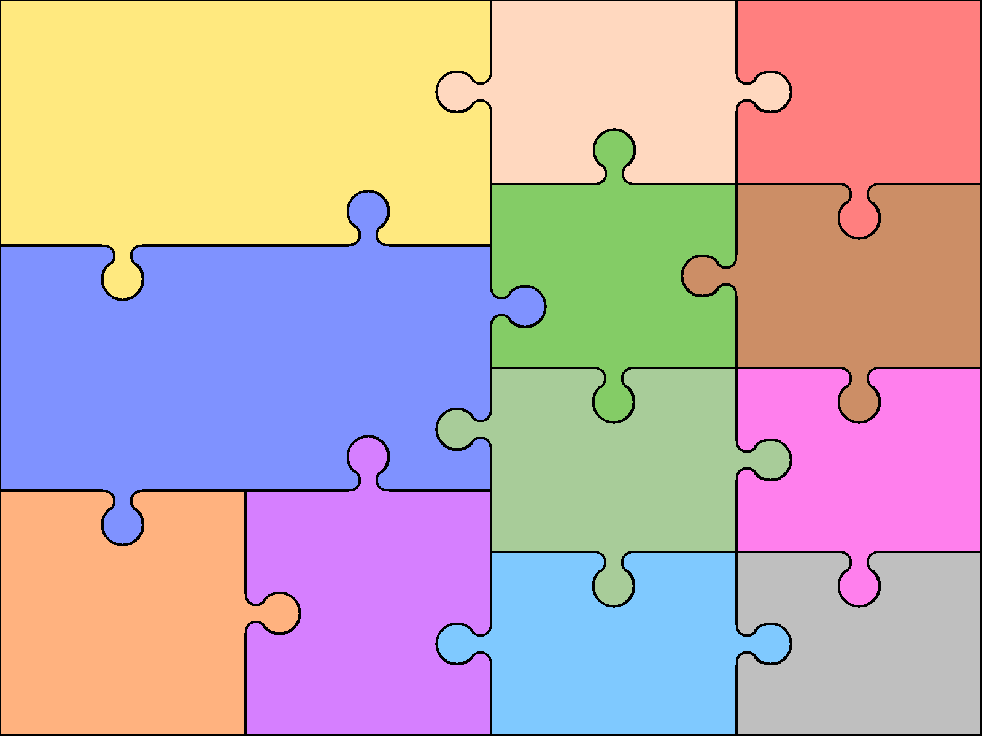  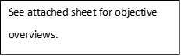  The topics we will be covering in literacy this year are:  - Labels, captions and diagrams.  - instructions  - information texts  - sense poetry  - letter writing  - recounts  - traditional tales  - news reports | English  Along with our units of work, we will be focusing heavily on our spelling, grammar and punctuation.  The children will do a half hour reading slot each day and we will have a weekly guided reading lesson where we will focus on developing children’s comprehension and reading skills. |  |  | Art & Design  This year in art we will :  - learn to stich  - mimic patterns  - use overlapping shapes  - use different material  - weave | Computing  This year we will be learning about:  - internet safety  - algorithms  - programming  - control motion  - control drawings and text  - use power point  - use a database
 |  |  |  | Design & Technology  This year we will be  - Using tools  - joining materials  - strengthen objects  - use leavers  - use mechanisms  - design, evaluate and model  - use models  . | Geography  This year we will be learning about:  - compasses and directions  - maps  - oceans and seas  - comparisons to our local area  - the equator and North Poles  .
Mathematics

As we teach Year One and Two in the same class we follow two sets of objectives. These are in the National Curriculum 2014.
 |  |  |  | Modern Languages  We do not do German lessons.  Physical Education  In PE this term the children are  learning with Miss White. | Music  In Music we will be looking at:  - pitch and volume  - singing accurately  - creating a rhythm  - controlling sounds to make an effect  - identify a beat  Religious Education  Mrs Webb will be teaching this to start.  This year they will cover:  - signs and symbols  - special stories  - special things that help worship  - how to care for others
Science  This Year we will learn about:  - different seasons  - the suns movement  - light and shadows  - types of animals (mammals, reptiles)  - Classifying animals  - using scientific language  - planning investigations  - identifying plants and trees  - making observations  - some properties of materials |  | History  This year we will learn about :  - famous people and events  - how technology, homes and toys  - have changed  - -use historical vocabulary  - -make comparisons  - use a time line

