Year 1 Home Learning Log
Please complete one activity per week and send pictures to our class email hollyleaves@littledean.gloucs.sch.uk. Home Learning is due by Thursday. The children will have the chance to share any of their homework activities on a Thursday Afternoon. I hope you have lots of fun working through these. Six completed activities will earn a prize! Please continue to practice reading and spellings for tests on Thursday. Thank you.
Ways to learn | A | B | C | D
OUTDOOR LEARNING  I enjoy hands on activities | Find some leaves or twigs. Can you arrange them in order of height? Can you use a ruler or tape measure to measure their length? | Ask a family member to take you for a walk in the woods, make some bark rubbings with some wax crayons of some trees you find interesting. Can you find out which tree your rubbing belongs to? | Flower and leaf printing/collaging – choose some flowers or leaves which you like the look of. Can you make a picture using different coloured paints and the items you’ve collected. | Have a go at making 2D shapes by tying together twigs with string!  Or 3D shapes using marshmallows as the corners and sticking in cocktail sticks.
MATHS AND SCIENCE  I enjoy working with numbers and science | Can you practice counting to 10, 20, 30 and 40. Can you put the numbers in order? | Look at the 5 Food Categories:  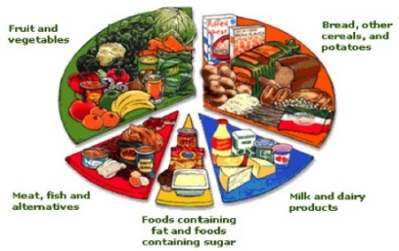  Now look in your fridge at home, can you sort the food in your fridge into the 5 different food groups? | Can you design a healthy meal and help an adult to cook it? Take some pictures or draw your food and write about how it tasted! | Grow some cress, take pictures and/or observe how it grows.
SHARED LEARNING  I enjoy working with others | Go with an adult to a shop. Can you count out the right amount of money to pay for the items you need? | Ask someone older than you about stories they remember from when they were little. Write or draw about their story. | Organise a movie night with your family. Work together to make ‘snack bowls’ and share the snacks equally between everyone’s bowls. | With the help of the internet, research a traditional tale from around the world.
CREATIVE LEARNING  I enjoy art and designing | Paint your favourite character from a traditional tale. | Make a collage of your favourite scene from a traditional tale. | Make a setting in a shoe box or small box for a traditional tale of your choice. For example you could do Jack and the Beanstalk with a castle on the lid and a house in the base. | Make a mask of a character from a traditional tale – can you act out how the character is feeling with your mask on?
COMMUNICATION  I enjoy reading, writing and speaking | Can you draw your favourite character from a traditional tale and label them with at least four words that describe them. | Share some of your favourite books with an adult or a friend. You could visit the library to have a look at the different traditional tales they have there. | Talk to an adult. What makes you proud about yourself? | Can you tell or write your own version of a traditional tale? What if the Big Bad Wolf wasn’t so bad, or Cinderella didn’t lose a glass slipper?

