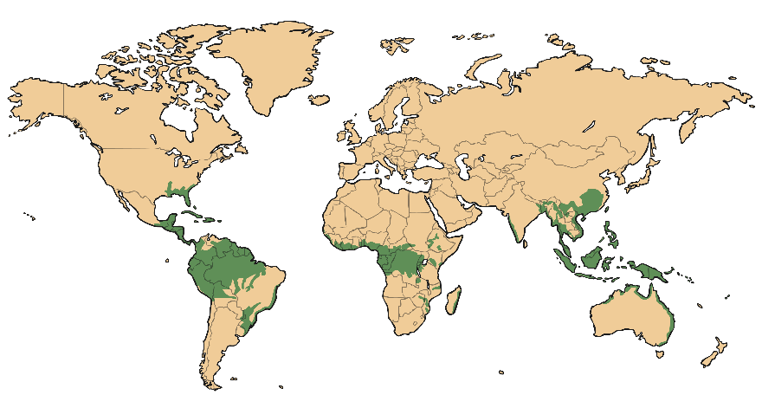
LO: to locate rainforests

Use an atlas to help locate countries which have rainforests. Can you name the rainforest?

