To write a setting description you need to think about all of things you can see and hear.
In this image you could see and hear:
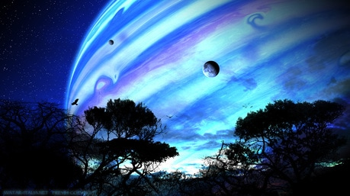
- Birds flying and squawking (you could think about why they are squawking, are they trying to send messages? Perhaps there is danger and they are trying to alert other species)
- Trees
- Colour of the sky
- Planets
- Moon?
- Stars

