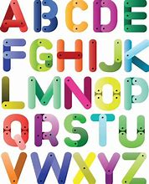

LO: To know how to say the alphabet in French

Using the song from You Tube to learn how to say the letters of the French alphabet and the table below, spell out your names in French. You can make a short video and send it to me. Once you have done your name, try and do some of your family’s and friends.

You may wish to write it out like this also:
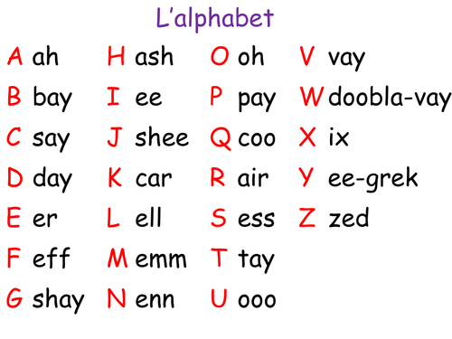
M emm
i ee
s ess
s ess

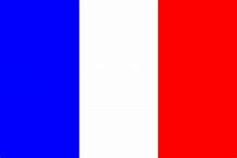
H ash
a ah
i ee
l ell
e err

