Lessons 5 – 7: Anansi and Tiger

Watch Lesson 5
With a parent helper, can you see how many compound words you can create?
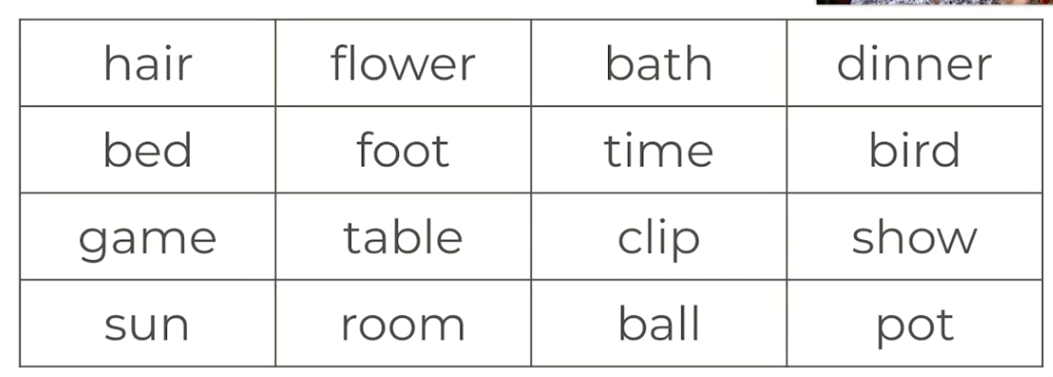

Can you or your home learning helper scribe the compound words below?
Can you find more than 10?

______________________________________________________________________________________________________________________
______________________________________________________________________________________________________________________
___________________________________________________________________________________________________________________________________________________________________________________________________________________________________________

Summarising the story

A summary is a short recap of all of the key points, but with no extra detail. We should be using a few words as possible. A good way of doing a summary is using question words.

What is happening? This is our action question and what we are focusing on the most in this unit.

With a parent helper, read through the text along with the video. Have a look at the summary table I have created below.

Who? | Anansi, the queen bee
Where? | The beehive
When? | After talking to Tiger at the beginning of the story
What? | Anansi is calling out to the bees.
Why? | Anansi is calling out to trick the queen bee
How? | Anansi says ‘ Is it true that you bee’s squabble all the time?

Now I have put all the key points into one sentence.

After talking to Tiger, Anansi travel’s to the Queen Bee and tricks her by asking her if bees squabble all the time.

Read through the next passage. Can you work with an adult helper to complete the summary table?

Year 1 – complete the missing parts of the table to complete your summary

Who? | Anansi, the queen bee
Where?
When? | After talking to Tiger at the beginning of the story
What?
Why?
How? | Anansi convinces the bees to fly into the barrel where they become trapped!

Now, with you parent helper, can you have a go at completing a summary sentence?

______________________________________________________________________________________________________________________
______________________________________________________________________________________________________________________

Year 2 - complete the missing parts of the table to complete your summary

Who? | Anansi, the queen bee
Where?
When?
What?
Why?
How?

Now, with you parent helper, can you have a go at completing a summary sentence?

______________________________________________________________________________________________________________________
______________________________________________________________________________________________________________________

Lesson 6 – To box up for purpose
Make sure you have your story map handy for today’s activity, you will need to use it. Listen to the story and look at your own story map for reference. After listening to the story, can you retell the story all by yourself, just using your story map to help you?

Today we are going to ‘box up’ our story. Remember, the purpose of this unit is to create action that is clear.

Purpose
Action that is clear

Describe the action of characters so it is really clear to understand what is happening, at a suitable place. This means we don’t rush the story, and we don’t make it too long either. We do this by writing:
- what happens in a clear order,
- where and when something happens,
- adjectives (describing words) to add more detail.

Your boxing up template is on the next page. I have changed the ‘notes’ column to say ‘key words’ instead.

Year 1

Story | Purpose | Key Words
 | Action that  is clear | Anansi,  fed up
beehive,
Queen Bee
Barrel
squabble
no tiger,
Anansi has the stories

Year 2

Story | Purpose | Key Words
 | Action that  is clear | Anansi,  fed up

Lesson 7 – Creating action

Watch lesson 7 and listen to the passage of text from the story.

Toolkit
Action that is clear
Describe the action of characters so it is really clear to understand what is happening, at a suitable place. This means we don’t rush the story, and we don’t make it too long either. We do this by writing:
- what happens in a clear order,
- where and when something happens,
- adjectives (describing words) to add more detail.

Verbs
Can you underline the verbs in the sentence below? Pause the video and have a go. Press play when you have finished.

The bees flew into the barrel.

Anansi called in his sing song voice.

Tiger gave the stories to Anansi.

Today we are going to be adding action words next to the characters. Remember we add -ed (not a ‘t’) to the end of a word now we are writing them in the past tense.

Character | Verbs – action word
Anansi | tricked
Tiger | prowled
Queen Bee | flew
Python | stretched

Now it’s your turn! Write a verb that describes a key action for each of the four characters.

Year 1

Character | Verbs – action word
Anansi
Tiger
Queen Bee
Python

Year 2 -Can you fill out the table independently?
How many different action words can you think of?

Character | Verbs – action word

