Date: | L.O. To listen and respond to the story: Anansi and the Tiger

Watch lesson 1. Can you complete the plot matrix below?
Where? | Who? | Problem?
Solution? | Ending? | Learning?

Date: | L.O. To retell a story from memory: Anansi and the Tiger

Watch lesson 2. Use this page to draw your story map.

Date: |  | L.O. To write questions for a character from the story Anansi and the Tiger
 |  |  | Adjectives | Conjunctions | Question mark
 |  |  |  |  |  | Traffic Light

Watch lesson 3. Choose a character that you want to role-play in an interview.
Write some questions that you would like to ask your chosen character from the story.
Look at the screen-shot of the slide below to help you when writing your questions. Remember a question sentence must end in a question mark.

_____________________________________________________________________________________________________________________________________________________________________________________________________________________________________________________________________________________________________________
Date: |  | L.O. To use and to join two clauses together
 |  |  | Adjectives |  | Conjunctions
 |  |  |  |  |  |  | Traffic Light
Year 1: Watch lesson 4.
The conjunction and helps us to join two different sentences together.
Have a look at the example sentence:
Anansi decided to trick the Tiger and went to his cave.
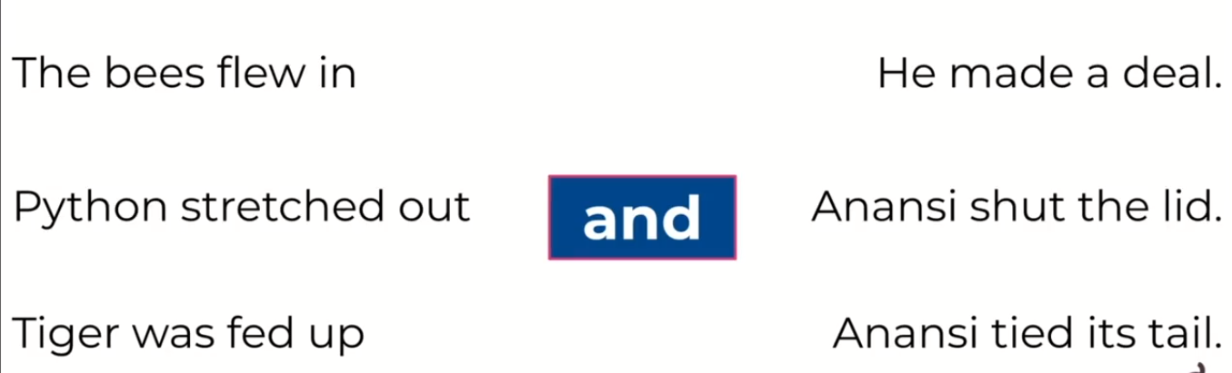
Can you join the two different clauses (part of a sentence) together by drawing a line?

Finish the sentences and use and to join the two actions together.
Tiger prowled out of his cave and___________________________
____________________________________________________
The bees flew in and ____________________________________
____________________________________________________
Anansi went to Python ____________________________________
_____________________________________________________

_____________________________________________________
_____________________________________________________
Date: |  | L.O. To use and to join two clauses together
Independent writing |  |  | Adjectives |  | Conjunctions
 |  |  |  |  |  |  | Traffic Light
Year 2: Watch lesson 4.
The conjunction and helps us to join two different sentences together.
Have a look at the example sentence:
Anansi decided to trick the Tiger and went to his cave.
Can you join the two different clauses (part of a sentence) together by drawing a line?

Finish the sentences and use and to join the two actions together.
Tiger prowled out of his cave and___________________________
____________________________________________________

___________________and ______________________________
____________________________________________________

_____________________________________________________
_____________________________________________________

_____________________________________________________
_____________________________________________________

