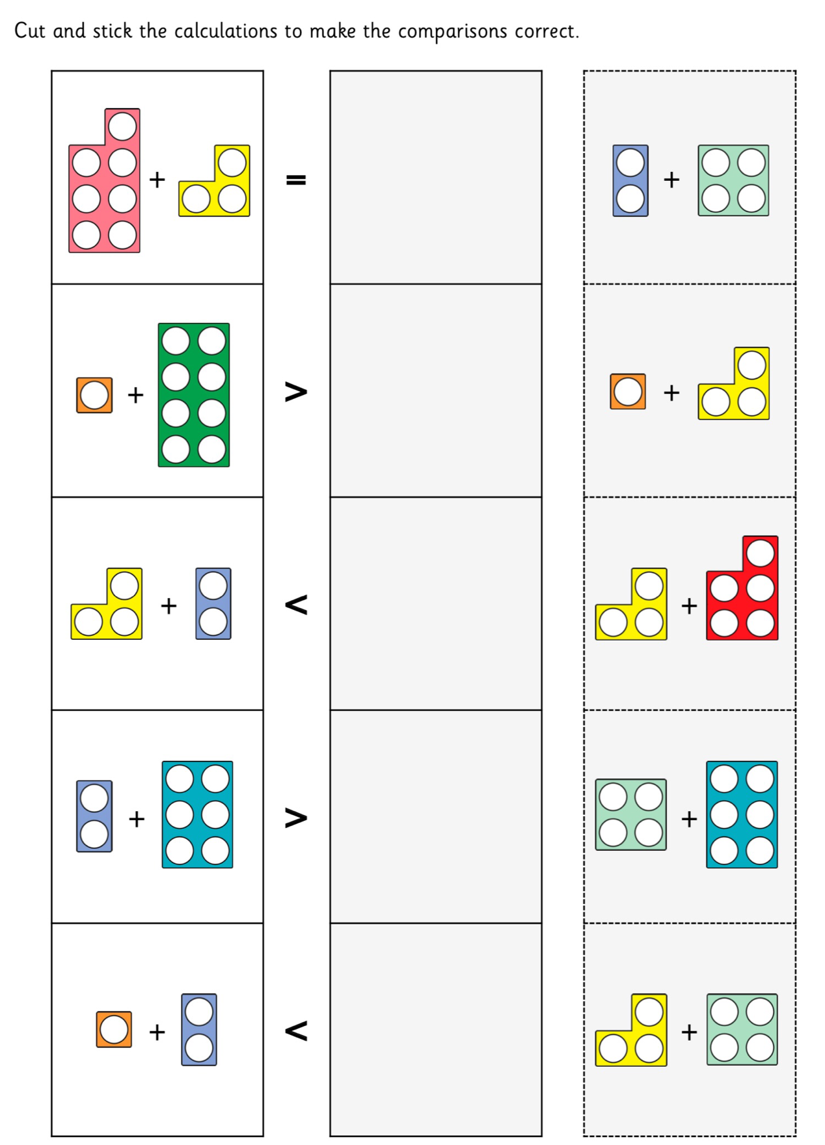
12th January 2021
Learning objective: I can compare number bonds.

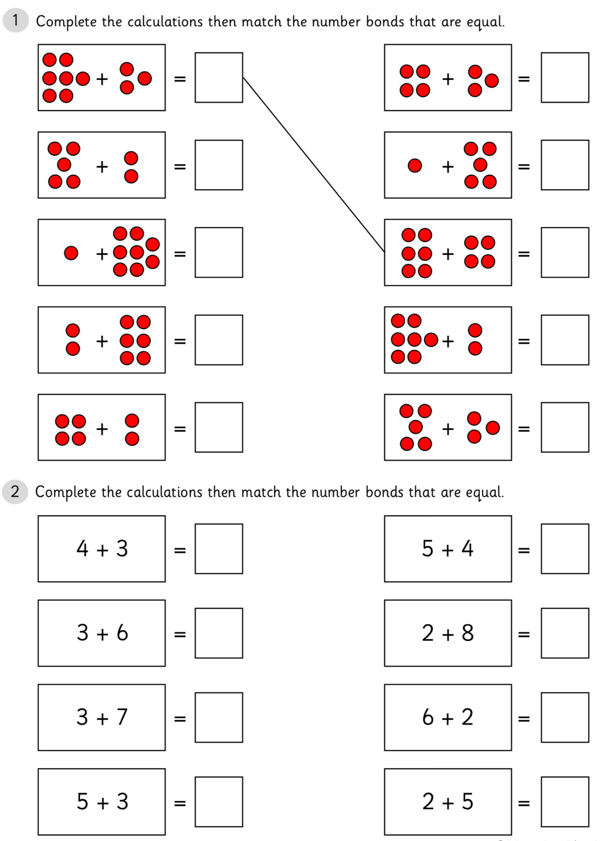
12th January 2021
Learning objective: I can compare number bonds.

