L.O. To use natural objects to create a portrait
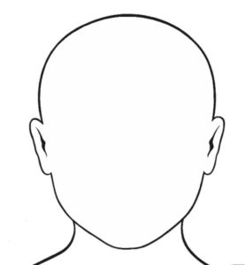
Use some natural objects you might find in your garden or on a local walk. Lay them on top of the template to create a portrait.

