LO: To recognise homonyms. Use the chart below to demonstrate that you understand the two meanings behind each word. Draw a picture to show what the word means and then write a sentence using that word next to the picture.
 | Pictures | Sentence
Wave | 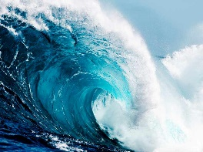 | The swimmers were stuck in a huge tidal wave!
 |  | The man needed to wave so the bus would stop.
Safe
Bat
Watch

Challenge homonyms:
 | Picture | Sentence
Train
Book
Age
Bark
Rose

