15.7.21
LO: To label parts of Stonehenge
_________________________________________
These are the oldest stones. They are a special colour and form one circle inside and the outside circle and another inside the horseshoe.

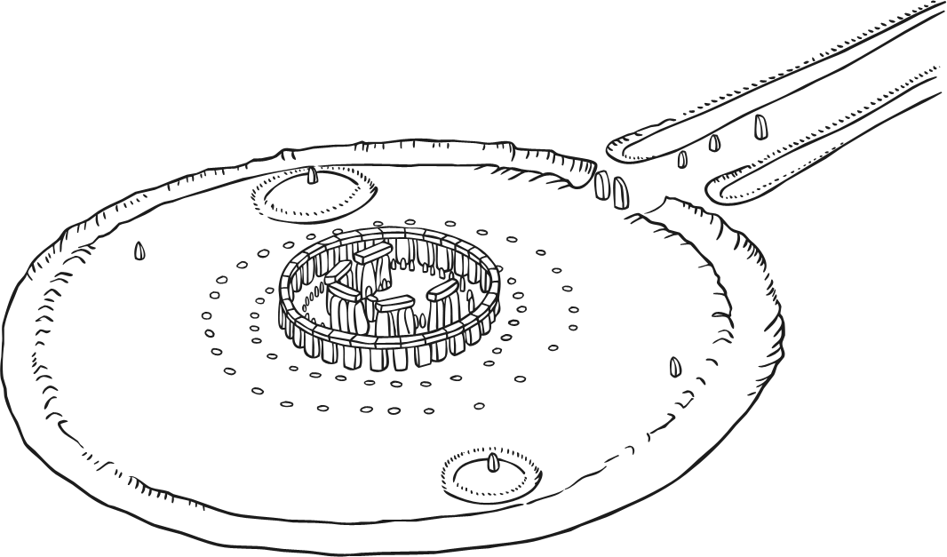
___________________________________
This leads the from the River Avon to Stonehenge and is the entrance to the monument.

_________________________________
This is the entrance to Stonehenge.
_________________________________________
This is made from 30 standing stones. A ring of horizontal stones sit on top of them.
__________________________
Five stones that are arranged in a special shape.
__________________________________________
A ring of chalk pits that was discovered around the stones.

