Tuesday 2nd March 2021
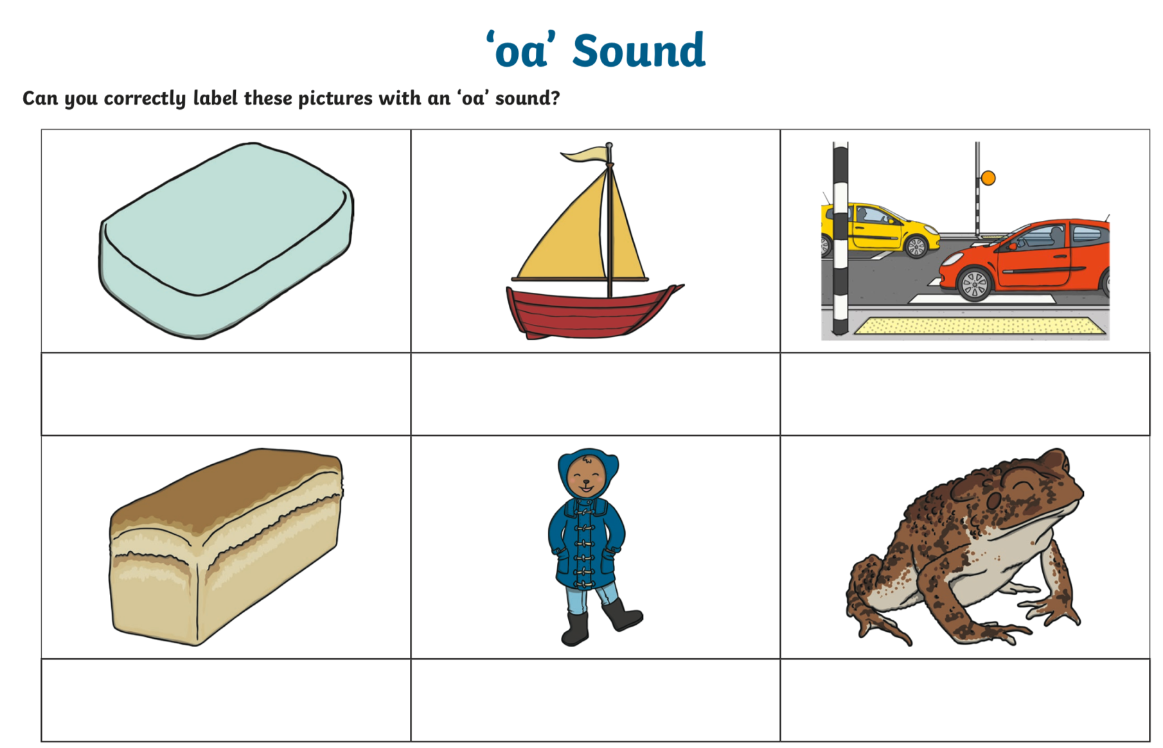
Learning objective: I can correctly spell words which use the oa digraph.

