A true dragon never cry’s

One day there was a small, weak, helpless dragon with green as grass eyes. Actually, he wasn’t weak any more he was fit and strong and was ruling the pack of Fiknesses [Fiknesses are a type of dragon] One day, there was a challenge and a big one, a male dragon called Madadon had had a grudge on Exodeus [Exodeus was pack leader] for ever. Suddenly a crowd gathered to see them fight. “Your still weak” said Madadon with anger in his eyes “You wish with all your heart” said exodeus. BANG “What?” said exodeus with dead eyes. “I don’t understand”
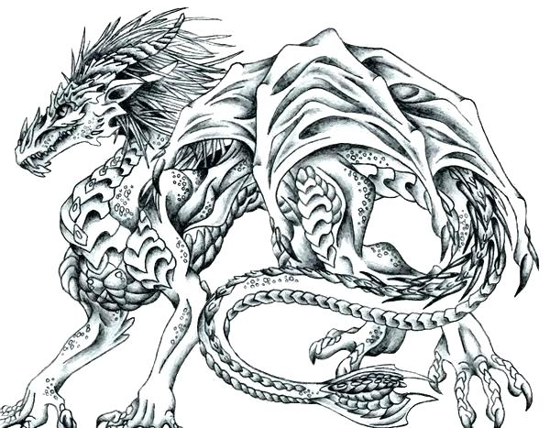
“Ha” said Madadon “I win I win” Madadon picked up and chucked him in the river “Have a swim ha” said madadon
“I’m sorry” exodeus said as the last dragons left. Exodeus fell and fell and fell until he felt something on the sea bed he felt it suddenly he was being flown through the air by a little boy. For some reason he didn’t stop. Then he felt something, something hard something old and sharp exodeus suddenly was being sucked through a gate way BOOM. Again, he felt a person was on his back but nothing was. He was lay on a bed and people were looking at him. “What is it”
“I don’t know”
“Is it a dragon”
“Is it a horse” at this exodeus started flapping his wings and nearly nocked out a girl. “roar” screamed Exodeus. “Wow” said a little boy. Exodeus put his wing down for the boy to get on and he did he got on. Exodeus bounded up and broke the
Window. Exodeus flew out with the boy on his back.
RATATAT
RATATAT
RATATAT
RATATAT
Something was shooting him the boy screamed “it won’t heart you.” Exodeus fell and fell and fell on to the floor the army force picked him up and took him to area 1003445373 what was happening exodeus was thinking. Suddenly, Exodeus woke up but he wasn’t in area 1003445373 he was in bed at home.

