Harry potter and the philosopher’s stone



A stunning book with lots of content for children and a very good imagination I give this book 5 out of 5 stars.

**This is the front cover of the book**

Book review by George

Book by j.k. Rowling

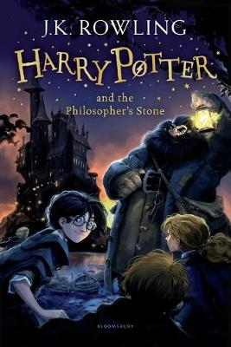

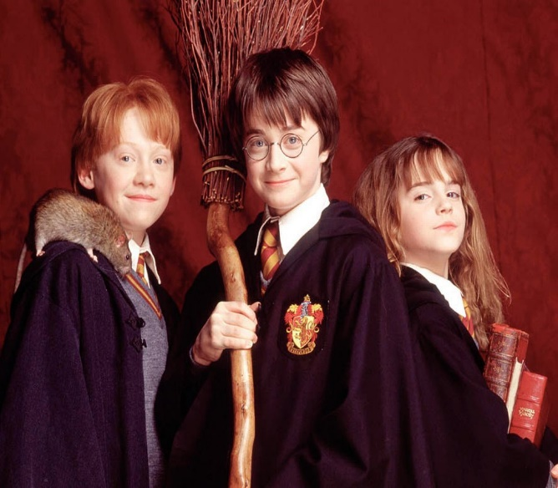

The main events are:

* Harry figures out he is a wizard
* Harry goes to a magic school
* Harry knows someone is going to steel something
* He goes through a trap door
* He stops the person
* He wins

Everyone’s favourite characters are the three friends harry Hermione and Ron. My favourite is Harry because he Is very brave.

The main events are harry goes to a magic school then he fiends a door someone is going to steal something he goes through the door he stops the bad guy.