|  |  |  |
| --- | --- | --- |
| 12.1.21 | L.O. To be able to multiply by making equal groups. | Traffic Light |

How may pairs of socks?

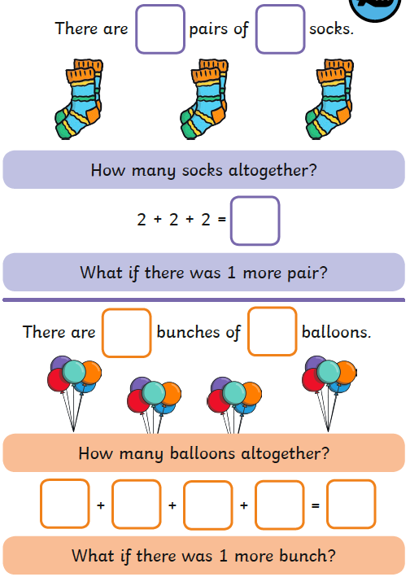

How may cakes?

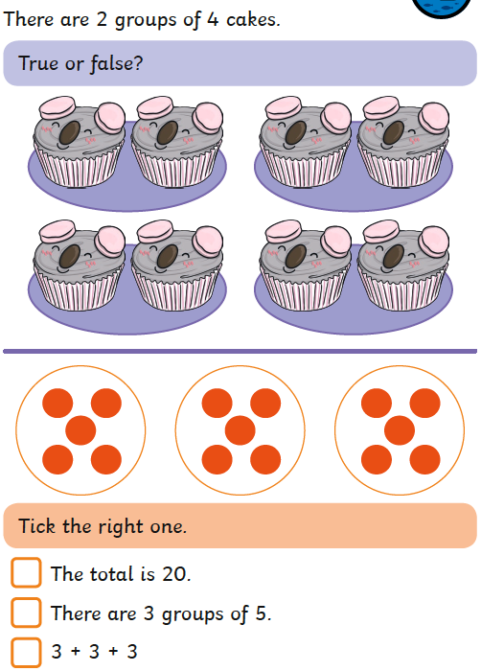

|  |  |  |
| --- | --- | --- |
| 12.1.21 | L.O. To be able to multiply by making equal groups. | Traffic Light |

How may plates would I need for 30 cakes?

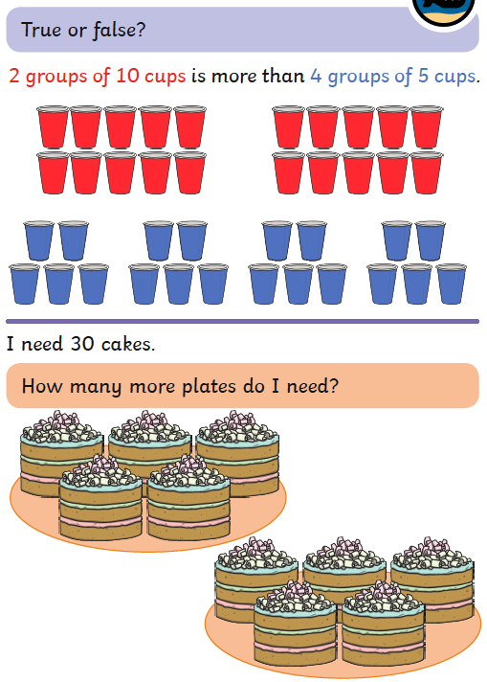

Use the space below to help show your working out

|  |  |  |
| --- | --- | --- |
| 12.1.21 | L.O. To be able to multiply by making equal groups. | Traffic Light |

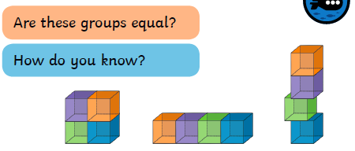

Match the labels to the picture

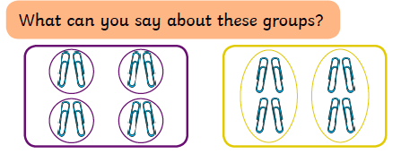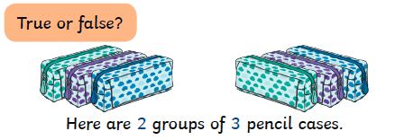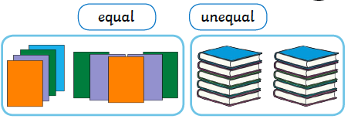

There are ____ groups of _____ paper clips.

There are ____ groups of _____ paper clips.

True or false?

|  |  |  |
| --- | --- | --- |
| 12.1.21 | L.O. To be able to multiply by making equal groups. | Traffic Light |

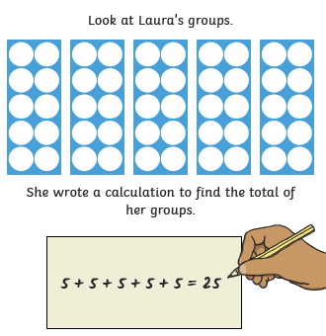

Can you complete the sentences?

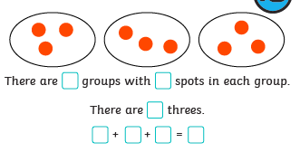

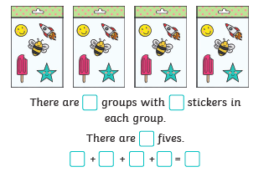

Do you agree with what Laura has written? Explain your answer.

Can you show what Laura **should** have written?

|  |  |  |
| --- | --- | --- |
| 12.1.21 | L.O. To be able to multiply by making equal groups. | Traffic Light |

Look at the pictures below. Can you solve the puzzles and write a repeated addition sentence for each one?

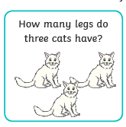

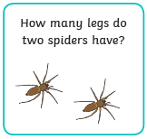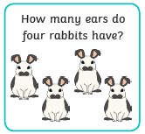  
  
  
  
  
  
  
  
  
  
  
  
  
  
  
  
  
  
  
  
  
  
  
  
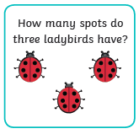

There are ____ groups of _____ legs.

___ + ____ + ____ = ______

There are ____ groups of _____ spots.

___ + ____ + ____ = ______