Here are some ways to support your child’s learning at home. Feel free to take any pictures of them completing their home learning and please email them to hollyleaves@littledean.gloucs.sch.uk so they can share what they have done!
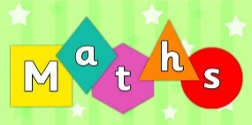 | - Cooking – using cups as measurement allows the children to count in ones  - Sharing food – “one for me, one for you” or “I’ve got two potatoes but you’ve only got one. How many more do you need to make it fair?”  - Ordering and comparing – e.g. go on a stick hunt and order the sticks in size  - Following a shopping list – e.g. can you get three tomatoes?  - Read number themed stories using props – Goldilocks and the Three Bears (set out their breakfast table with three bowls etc)  - Sing or listen to number themed songs using props – 10 green bottles  - Practice forming numerals (can use different items like beads or buttons or chalk outside to make it more fun)  - Shape hunt at home or out and about (2d and 3d)  - Estimating how many items there are. Check afterwards by counting.  - Questioning what’s one more than a given number (“You have 3 biscuits but I have one more than you. How many biscuits do I have?”)
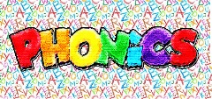 | - Use sounds rather than the names of the letters  - I spy with sounds using initial sounds (not letters) or “I spy with my little eye a d-o-g” so the child can blend  - Find sounds in signs e.g. when walking around town, can you see a “s” in this sign?  - Find items with the same sound – go on a “s” search (socks, sticks, sofa)  - Use magnetic letters to build cvc words (consonant vowel consonant words e.g. cat)  - Clapping sounds in a word (c-a-t would be 3 claps)  - Robot talk – talk like a robot but you can only sound words out using individual sounds (b-a-t not bat). See if the child can then work out what the robot word is.  - Phonic songs (Old Macdonald had a farm, ee I ee I oh, and on that farm he had a p-i-g. What did he have on his farm?)  - Sound flash cards – showing sounds in random order
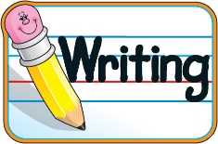 | - Rainbow writing their name – writing it in lots of different colours making sure they have a capital letter at the beginning and lower case in the middle.  - Write letters to people or characters in a story  - Messy writing (writing in shaving foam, sand or paint)  - When making a model, write on a post-it note to describe what you have made  - Label pictures you have drawn  - Draw then label your favourite characters from the story you are reading.  - Put paint in a zip lock bag and using your finger write words  - Rainbow writing - trace a word as many times as you can, using a different colour each time  - Use magnetic letters to build words  - Draw a speech bubble next to a character and write what they are saying  - Before you go shopping, write a shopping list for the items you need.
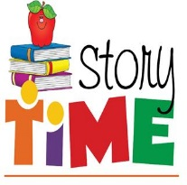 | - Make a scene from a story you have read  - Write alternative stories together (change setting, characters or the ending)  - Act out a familiar story  - Read a story and draw your favourite character or setting  - Sequence a story (e.g. Get animals that are the same as characters in The Gruffalo. Order the animals in order that they appear in the story)  - When reading a story, leave a blank for a word. Can the child fill in the gap?  - Discuss favourite stories  - Visit the library and enjoy sharing the books you have chosen
- Taster day – Children taste different types of food. Can do this blindfolded to make it more exciting and try and guess the different foods
- Make an obstacle course and complete the different movements to get to the end. Encourage the use of prepositional language. Can they guide someone else through the course when blindfolded?
- Play throwing and catching games with different objects (balloons can be fun)
- Follow movements. Brain breaks or GoNoodle on youtube is good for this
- Using scissors, create a collage
- Make pictures by picking up different objects such as buttons (picking objects up with a pincer grip develops muscles in order to write)
- Quiz members of the family or friends about their occupation.
- Grow a flower/plant and observe the changes over time.
- Complete a game on the computer/tablet (top marks is a good site for math games). Can they use the mouse?
- Create a bug, frog or bee hotel! There is some great information on how to do this on the RSPB website. Pinterest also has some good ideas.

