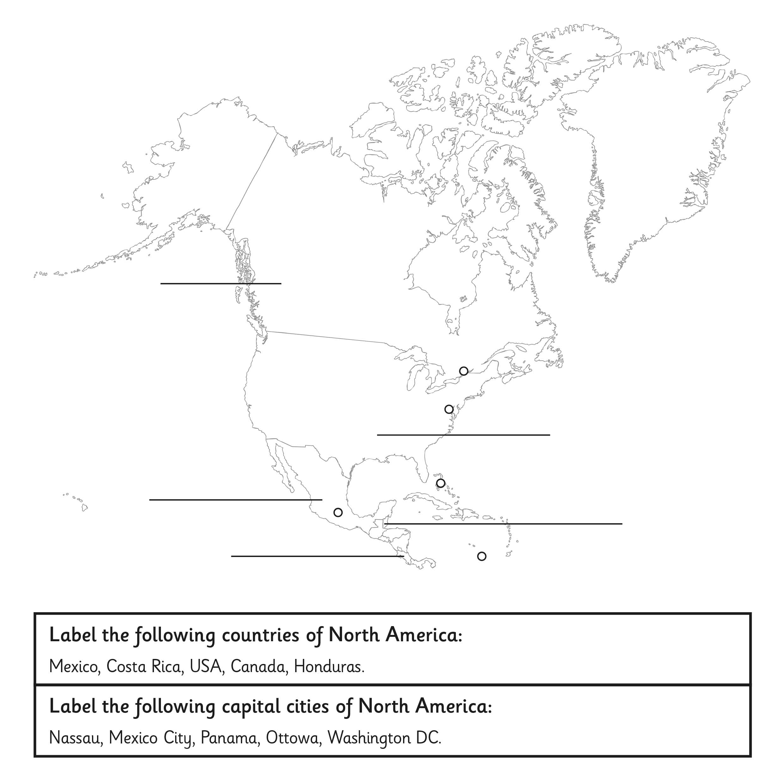

LO: to label the countries and capital cities of
North America

