LO: to write a Wikipedia entry for Vincent Van Gogh.

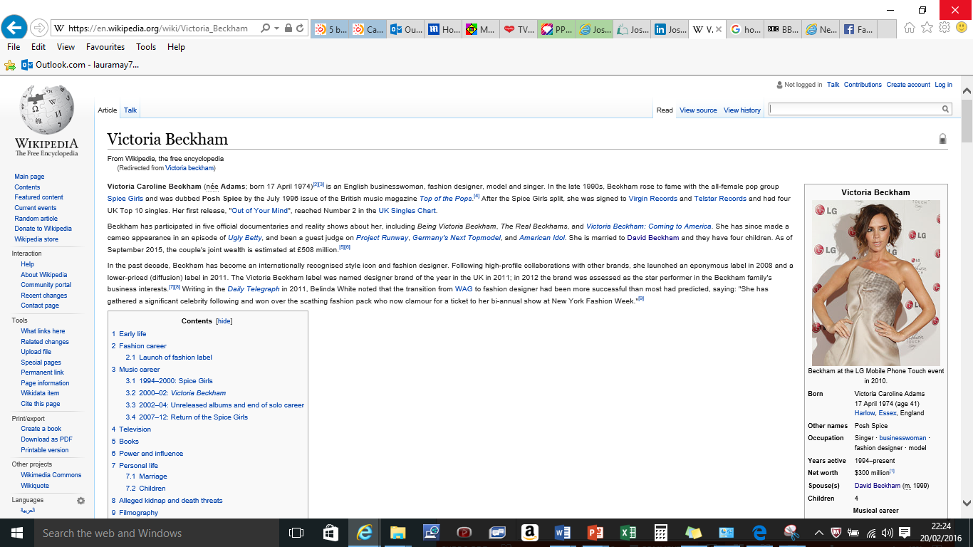

Vincent Van Gogh

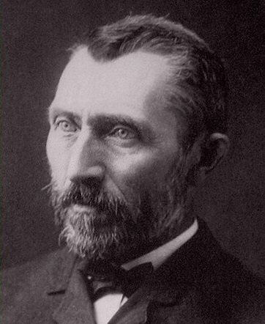

Born:

Died:

Nationality:

Siblings: