Date: ..................................................................
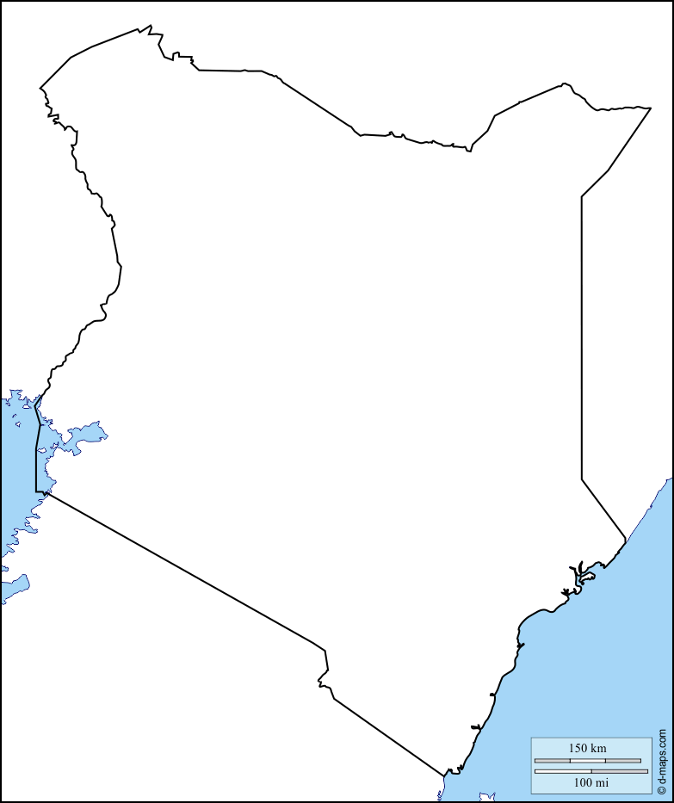
L.O. To develop my locational knowledge of Kenya. To use an atlas map to label important places and landmarks.
Key:

