Loving one another, building each other up

This is a story about a man in the bible called Nehemiah who helped rebuild a wall around Jerusalem to help his friends stay safe. Read the story or ask a grown up to read the story to you.
A Time to Build
God’s people were working as slaves away from their home, Jerusalem. One day God decided. ‘It’s time for my people to come home to Jerusalem.’
So God whispered in the ear of the king of the country where God’s people were slaves. ‘Send them home,’ God said.
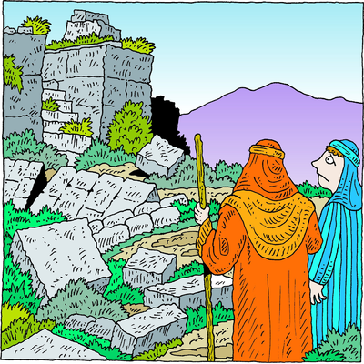
So the king did. And thousands and thousands of people returned to Jerusalem. There was a lot of work to do when they got to Jerusalem: rebuilding their houses – so they had somewhere to live: rebuilding the temple – so they had somewhere to worship God: rebuilding the walls around Jerusalem – so they had somewhere to hide from their enemies.

It was hard work. They had no end of problems. For a long time it looked as if it would never be done.
God wanted to help his people so he whispered in the ear of a man who worked for the king who could get the kings attention.
The man’s name was Nehemiah. His job was to bring the king his wine each day. The king trusted him very much, and was puzzled when Nehemiah arrived one day, cup in hand, with a sad frown on his face.
‘What’s the matter, Nehemiah?’ the king asked. ‘Why do you look so sad?’
Nehemiah whispered a prayer before he answered.
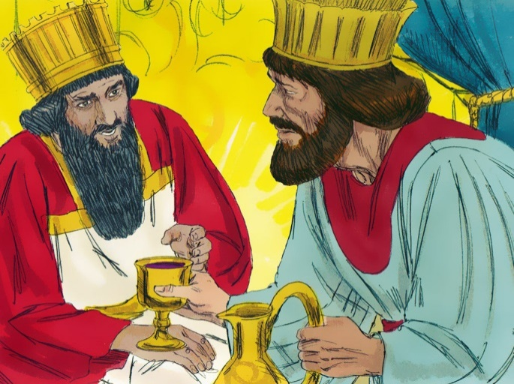
‘Forgive me, Your Majesty,’ Nehemiah begged. ‘I know it is my duty to smile in your presence, but I cannot. I have heard that my friends are suffering in their homeland. The walls of Jerusalem are broken down and I know that I could help, if only I could go and join them.

‘I know also that you have wood and stone which would make their job so much easier. Please, send me there with supplies to finish the job and bring an end to my friend’s suffering.’
The king thought long and hard. ‘Yes, Nehemiah,’ he answered. ‘You may go. But let me send some of my soldiers along to protect you on the way.’
Nehemiah thanked the king. He thanked God too. And he set off on his long journey.
When Nehemiah arrived, he found Jerusalem in a terrible state. But the people were pleased to see him.
‘Let’s build up these walls,’ he encouraged them. ‘For God is with us. He gave me courage to speak to the king. He persuaded the king to give us these supplies. And now God will help us finish the job.’

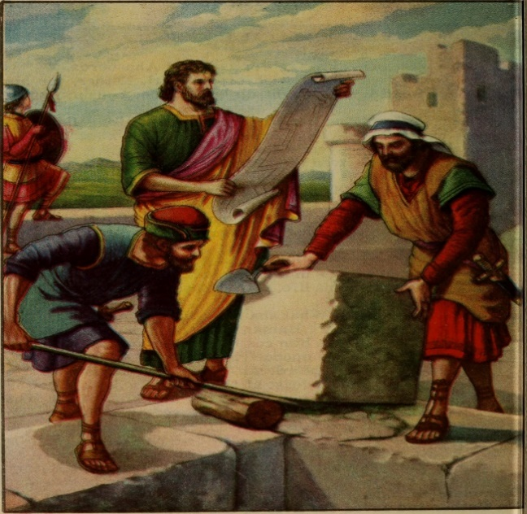

The people cheered and set to work. It still wasn’t easy. There were enemies who tried to stop them, but finally they finished. The walls were built. Their houses too. They had even finished the temple, where the people gathered to talk with God.
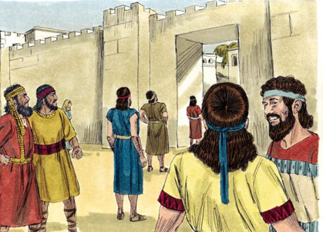

‘Thank you for bringing us home and bringing Nehemiah to help.’ they said.
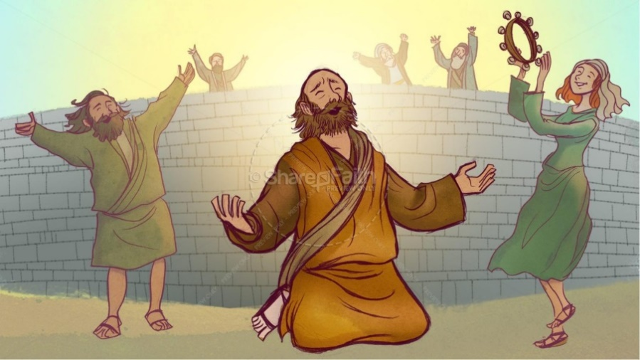

Activities
Nehemiah wanted to help his friends by building a wall to keep them safe.
Find some bricks, either Lego, Duplo or wooden blocks, or make some building blocks with cardboard boxes such as cereal boxes, and build a wall. As you build your wall think about your friends and family. Maybe put a sticky label on each brick with their names on. When your wall is built say thank you to God for them all.

Make a card or write a letter to people you know who are living on their own. Tell them about your wall so that they know you are thinking about them.

Write a prayer to God about the people you love, decorate it with drawings and then read it to God at bedtime.

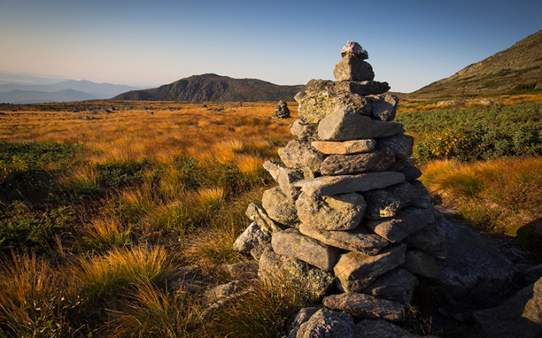

This is a picture of a Cairn.
A Cairn is a pile of stones which people build up on walks on hills like Snowdon in Wales. When people see a Cairn they add a stone to it to make it higher. Then when it gets foggy on the hill or it snows people can still follow the footpath by looking out for the Cairns. The Cairns keep them safe.

If you have a garden, see if you can find some stones to build a Cairn, the stones can be small ones. As you build remember your friends and family. Ask God to keep them safe.

