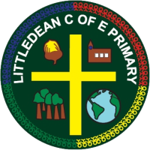

Name:

Our spellings are based on spelling rules and patterns that we have been learning in our phonics and grammar groups. It would benefit your child if they could practise their spellings at home as well as in school. Not only does it improve reading and spelling, but by practising these words, it also improves letter formation and muscle memory. The more a child practises spellings, the quicker they learn to read the word and the quicker muscle memory improves. As muscle memory improves, the spelling of words becomes more natural.
Spelling tests will be on a Thursday.
Test date:  28th February | Test date:  7th March | Test date:  14th March | Test date:  21st March | Test date:  28th March | Test date:  4th April
Sound: a-e  Bake  Cake  Late  Game | Sound: e-e  Pete  Theme  Complete  Even | Sound: i-e  While  Crocodile  Smile  Kite | Sound: u-e  Huge  Cube  Tube  Refuse | Sound: o-e  Phone  Home  Rose  Alone | Consonant clusters:  Frog  Glue  Grape  Plate

