Facts about dragons
Introduction
Long, long ago dragons roamed the world stomping and breathing fire. Every one probably loves dragons but you’re yet to see the destruction they can summon. Now sit back and relax while I tell you of a few dragons big and small, fat and thin.
Types of dragons
There are 8 types of dragons including:
5. Nano dragons
6. Sky dragons
7. Muntain dragons
8. sea dragons [biggest type]

- Cave dragons
- Tree dragons
- Domesic dragons
- Bog dragons

Some interesting dragons
Fire Starters
Fire Starters live in the forests they burn down but have no idea of what there doing when there burning they think it’s fun.
Type: tree
Fear factor:4
Attack:4
Speed:7
Size:2

Riproarers
Riproarers are a very dangerous species of dragon that hunt in parties of 4 or 6.
Type: cave
Fear factor:8
Attack:8
Speed:8
Size:7

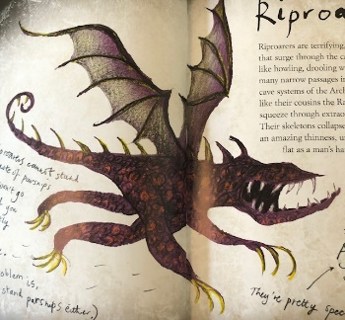
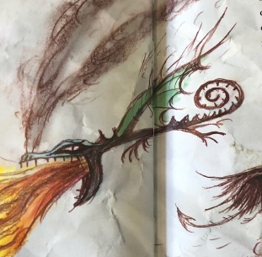

Thors Thunderers
These dragons are the most scary and evil they are thirsty for blood. This dragon is huge and mean.
Type: sea
Fear factor:10
Attack:10
Speed:9
Size:9
Sticky Worms
A Sticky Worm is twice the size of a boa constrictor. It is lethal to get good food for its babies.
Type: bog
Fear factor:6
Attak:6
Speed:3
Size:6

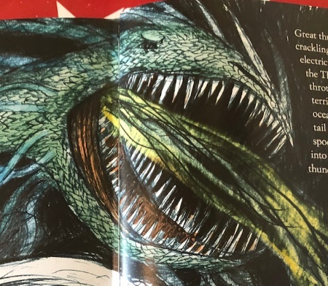
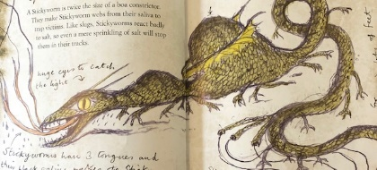
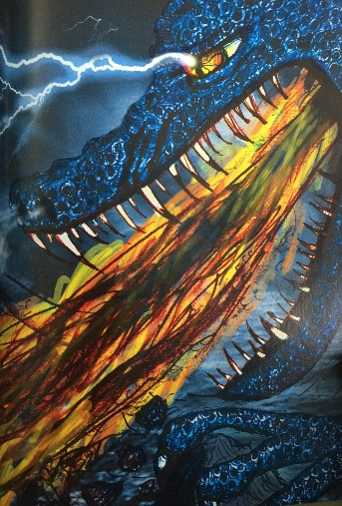
Seadragonus Giganticus Maximus
There is nothing to say about this dragon, apart from its
huge and dangerous.
Type: sea
Fear factor:10
Attack:10
Speed:10
Speed:10
Size:10

Dragon eggs
Dragon eggs look quite the same but not all of them are friendly because some of them
and breath fire straight into your face.
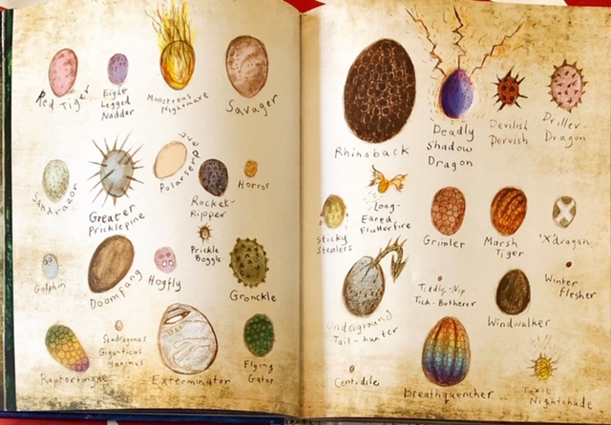
This is what all of the
dragon eggs look like

Dragon language
The dragon language is called dragonese [drag-on-ees]. Not many humans are able to speak it because they don’t have forked tongues.
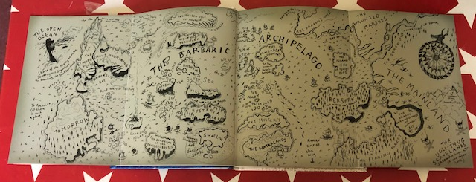
Map of the Dragons Archipelago
Some Dragonese
Dragon: yow me p-p-peepers undo. Translation: you woke me up
Dragon: wah is DA? Translation: what is that?
Dragon: wah DA? N-n-nomuny looky Translation: what that? that’s nothing
Dragon: me has b-b-buckets di belly-scream Translation: I am very hungry
This is the Barbaric archipelago the most intense and competitive group of islands. The dragons live all over this deranged community. Some live with their human companions and some roam the wild with extraordinary hopes of staying alive rushing through their veins.
Conclusion
Looking of what we have looked at today I would say I wouldn’t want one as a pet because some breath fire, some don’t, some hug you, some eat you. Could you ever be sure if your dragon is going to eat you!

