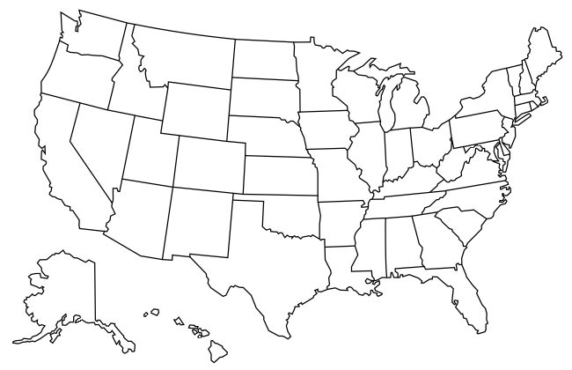
LO: to name the 50 states that make up the USA.
Key

