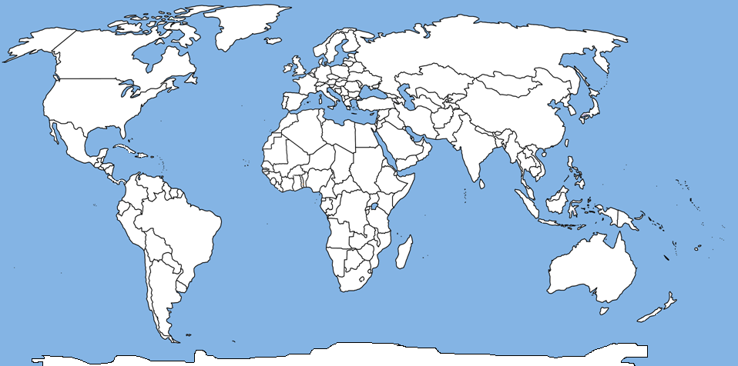
LO: To locate continents and oceans on a map of the world

Key

- Create a key showing the 7 continents and give 3 examples of countries within that continent, for example:

Africa : countries such as South Africa, Egypt and Uganda.

- Write on the names of the 5 oceans.

