Year 2 Maths – 23.2.21
Tuesday: L.O. To recognise and name 2D and 3D shapes
Watch lesson 1 on the White Rose home learning links and complete the activities below.
Draw a line to match the shape with its name

triangle hexagon circle octagon

Complete the Patterns

Which of these shapes is the odd one out? Draw a circle around your answer.

Write a sentence to explain why:
____________________________________________________________________________________________________________________________________

Which of these shapes is the odd one out? Draw a circle around your answer.

Write a sentence to explain why:
____________________________________________________________________________________________________________________________________

Look at the picture and colour in the shapes.

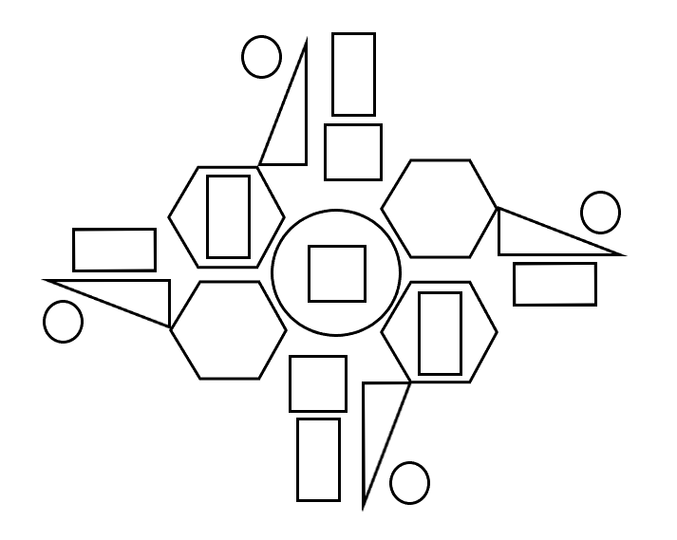
Circles = Rectangles = Squares = Hexagons = Triangles = Fill in the tally chart to show how many of each shape you can see
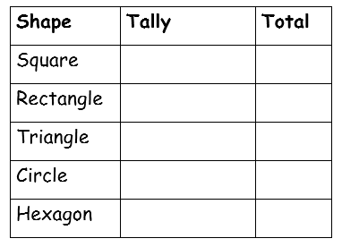

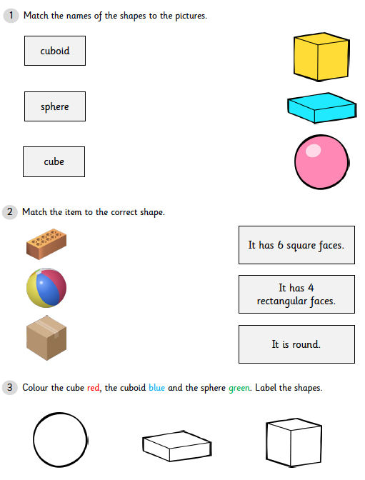

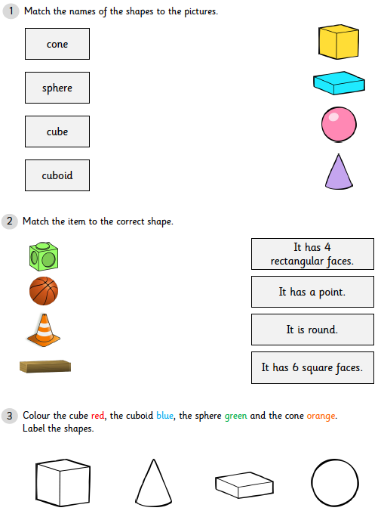

Wednesday: L.O. To be able to count the sides and vertices of a 2D shape.
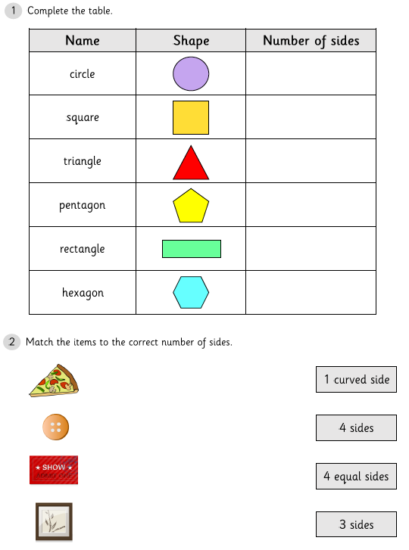
Watch lessons 3 and 4 on the white rose home learning and complete the following activities. The questions are star rated in difficulty level. Please note you are only asked to complete one set of star rated questions per day.

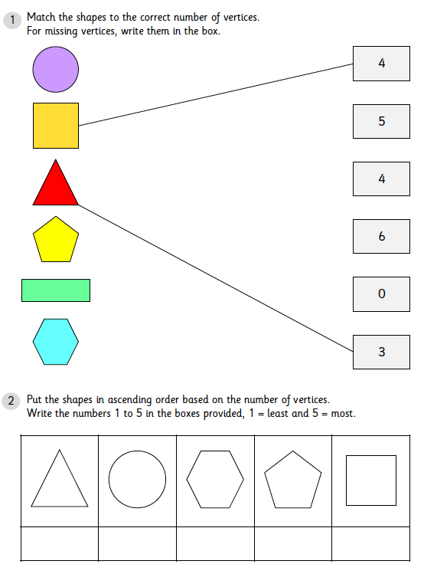

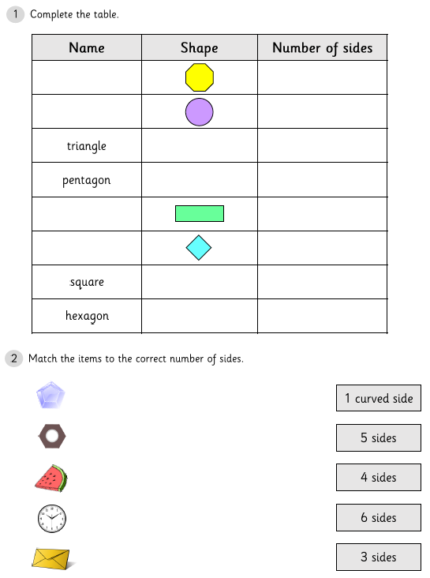

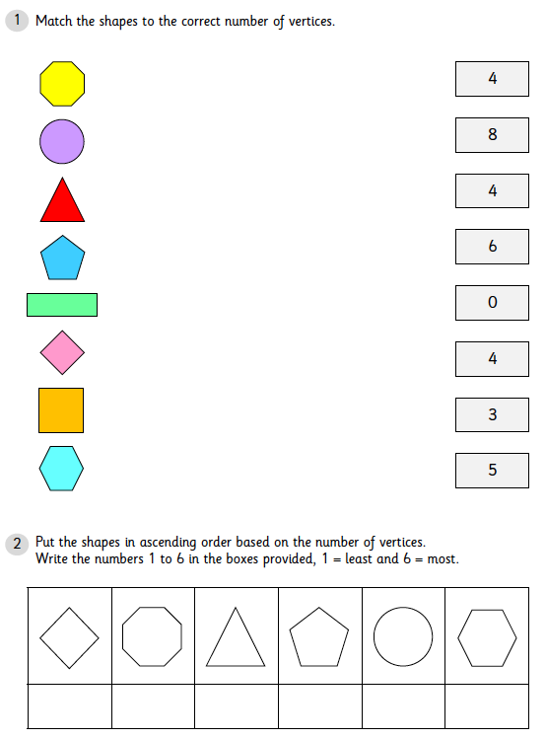

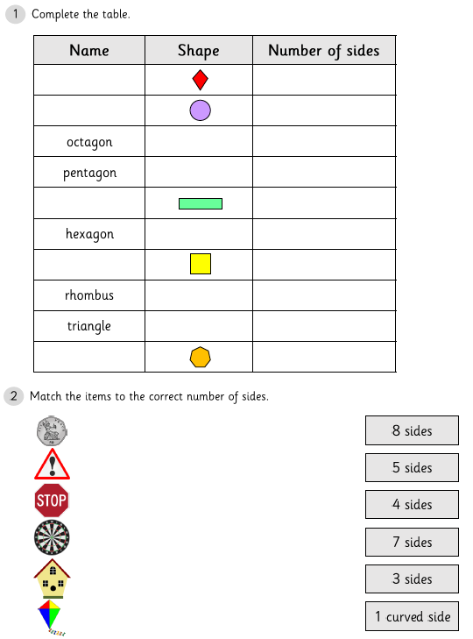

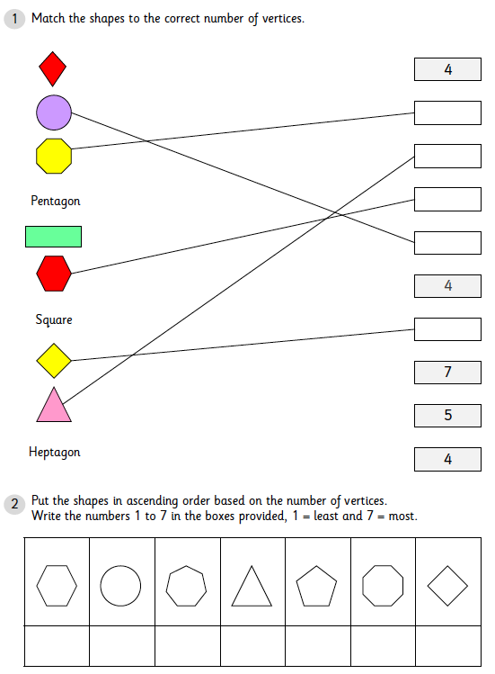

Thursday: L.O. To be able to identify 3D shapes within your home.
There are no videos to watch today. To consolidate your learning over the past two days, have a go at completing a shape hunt in your home.
