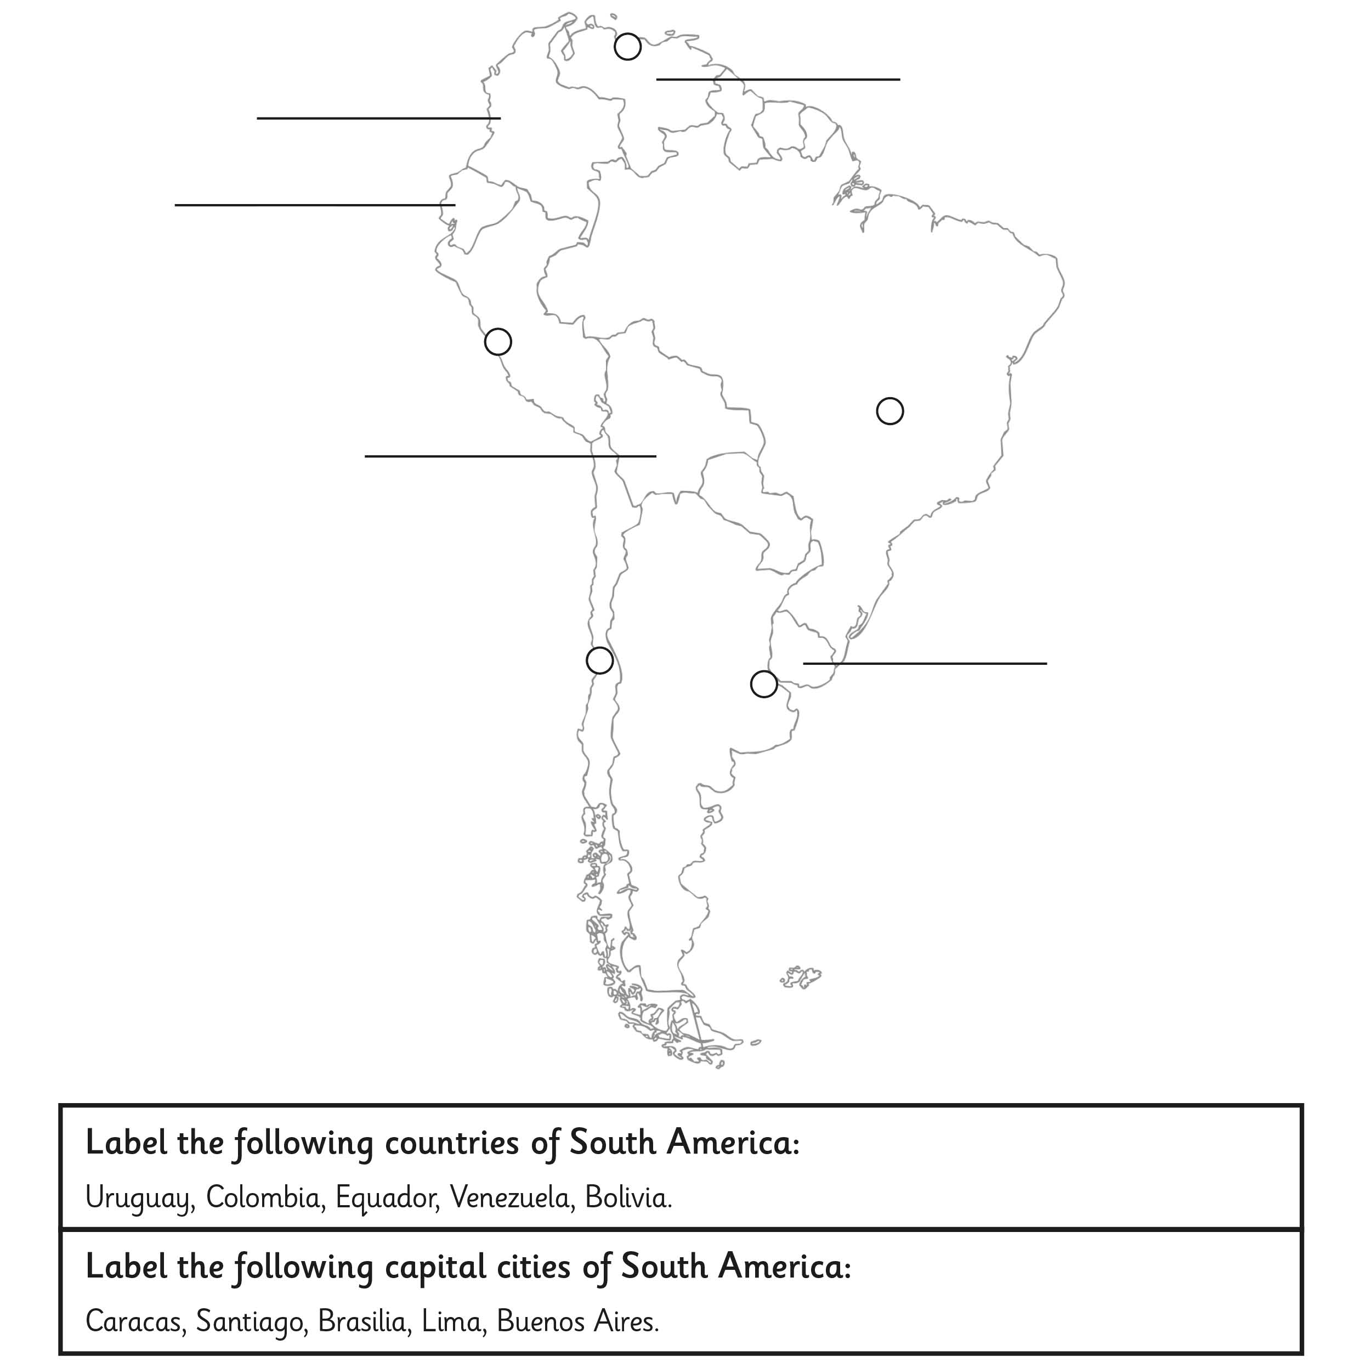

LO: to label the countries and capital cities of
South America

