Date. | L.O. To write a set of instructions for how to defeat a giant

This week you have been looking at writing a set of instructions for ‘How to Defeat the Fire Giants’. Follow lessons 8-10 and watch closely as the teacher models the writing process to you. However, instead of copying the original text, can you design and write instructions for how to defeat your own giant?

Have a go at drawing a picture of your own giant. It could be a water giant, stone giant, snow giant, woodland giant, or even a cloud giant. You can use these ideas if you want to, but feel free to develop your own!

My Giant is a ...................... giant. Draw a picture of your giant.

In the original instructions, it says:
‘Fire giants glow like the sun and sound like burning twigs’
This helps us to create a picture in our minds of what the giant looks like. Can you write a descriptive sentence about your giant on the lines below? What do they look like? Do they make any distinctive noises or have any special skills? Why do you need to defeat them?
______________________________________________________________________________________________________________________________________________________
______________________________________________________________________________________________________________________________________________________

Box up your own instructions. Use key words and images. Use the boxing up you did of the orginal text and copy the format, but change the fire giants to your own giant.

Much like when we looked at the frost giant (lesson 6) you might need to change your equipment. So instead of needing chillies to defeat the fire giant, to defeat the frost giant we needed ice cubes. Remember when boxing up, focus just on writing the imperative verbs and adverbs (ly words, how are you going to do it? Quickly, slowly, etc) in the box.

Pictures | Your key words
Introduction... | Introduction...
Equipment | Equipment (don’t forget to add an ajective in to describe each piece of equipment e.g. tall ladder)  To defeat the .................... giant you will need
 | First.....
 | Then...
 | Next...
 | After that...
 | Later....
 | Finally...

Following lesson 8: Use the next page to have a go at writing your own instructions. You may find it useful to use these sentence starters to help you. You can use the writing frame to help you, or write straight onto lined paper.

Introduction

Equipment

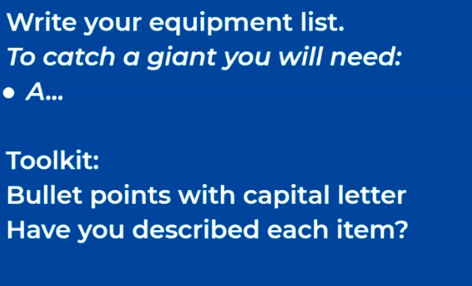

How to defeat the .............................. Giants.

Introduction

I_____________________________________________________________________________________________________________________________________________________
______________________________________________________________________________________________________________________________________________________
______________________________________________________________________________________________________________________________________________________

Equipment

To catch a ____________ giant, you will need:

- ______________________________

- ______________________________

- ______________________________

- ______________________________

- ______________________________

Following Lesson’s 9 and 10. Now it is time to write your own instructions. I have put some screenshots of the teachers tips to help you.
Don’t forget to follow your plan of your boxing up of your own giant. Look at the list of imperative (bossy) verbs if you’re not sure what to start your sentence with.
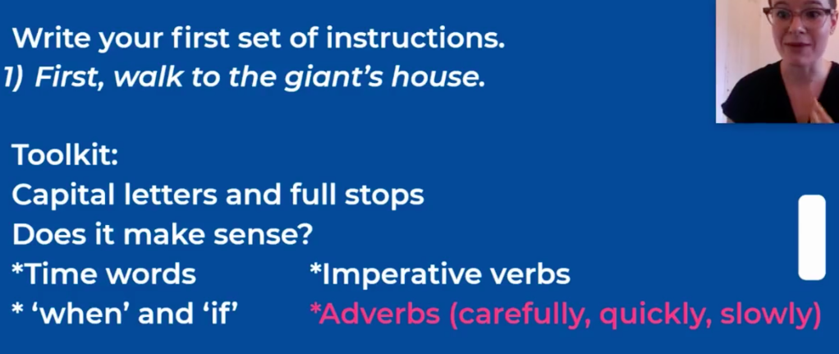
Can you use when or if in a sentence to create a subordinating conjunction?
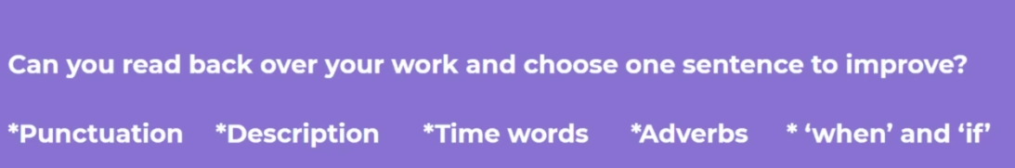

Instructions

1.____________________________________________________________________________________________________________________________________________________
___________________________________________________________________________

2.____________________________________________________________________________________________________________________________________________________
___________________________________________________________________________

3.____________________________________________________________________________________________________________________________________________________
___________________________________________________________________________

4_____________________________________________________________________________________________________________________________________________________
___________________________________________________________________________

5.____________________________________________________________________________________________________________________________________________________
___________________________________________________________________________

6.____________________________________________________________________________________________________________________________________________________
___________________________________________________________________________

7.____________________________________________________________________________________________________________________________________________________
___________________________________________________________________________

8____________________________________________________________________________________________________________________________________________________
___________________________________________________________________________

